**DAILY ONLINE ACTIVITIES SUMMARY**

|  |  |  |  |  |  |  |  |
| --- | --- | --- | --- | --- | --- | --- | --- |
| **Date:** | **21st May 2020** | | | | **Name:** | **K ISHA HEGDE** | |
| **Sem & Sec** | **4th sem** | | | | **USN:** | **4al18cs031** | |
| **Online Test Summary** | | | | | | | |
| **Subject** | | **MICROCONTROLLER AND EMBEDDED SYSTEMS (18CS44)** | | | | | |
| **Max. Marks** | | **30** | | **Score** | | **17** | |
| **Certification Course Summary** | | | | | | | |
| **Course** | **Digital security awareness** | | | | | | |
| **Certificate Provider** | | | **ALISON** | **Duration** | | | **2 hours** |
| **Coding Challenges** | | | | | | | |
| **Problem Statement:I have solved 3 problem statement** | | | | | | | |
| **Status: executed** | | | | | | | |
| **Uploaded the report in Github** | | | | **Yes** | | | |
| **If yes Repository name** | | | | **[http://github.com/iishaii/locked-down_coding](http://github.com/iishaii/locked-down_coding" \o "http://github.com/iishaii/locked-down_coding)** | | | |
| **Uploaded the report in slack** | | | | **Yes** | | | |

Online Test Details: (Attach the snapshot and briefly write the report for the same)

Certification Course Details: (Attach the snapshot and briefly write the report for the same)

Coding Challenges Details: (Attach the snapshot and briefly write the report for the same)

**Online Test Summary:**

Today **MICROCONTROLLER AND EMBEDDED SYSTEMS (18CS44)**

was conducted of first module. Total marks for the test was 30.



**Certification Course Summary:**

Today I started new certificate course through ALISON. I choose the concept of digital security awareness.I completed two modules and learnt about various types of security threats , threats to sensitive information and how to secure them.This module covered security of the computer,email and files.And at the end of each module , I solved the assessment and secured 100%.

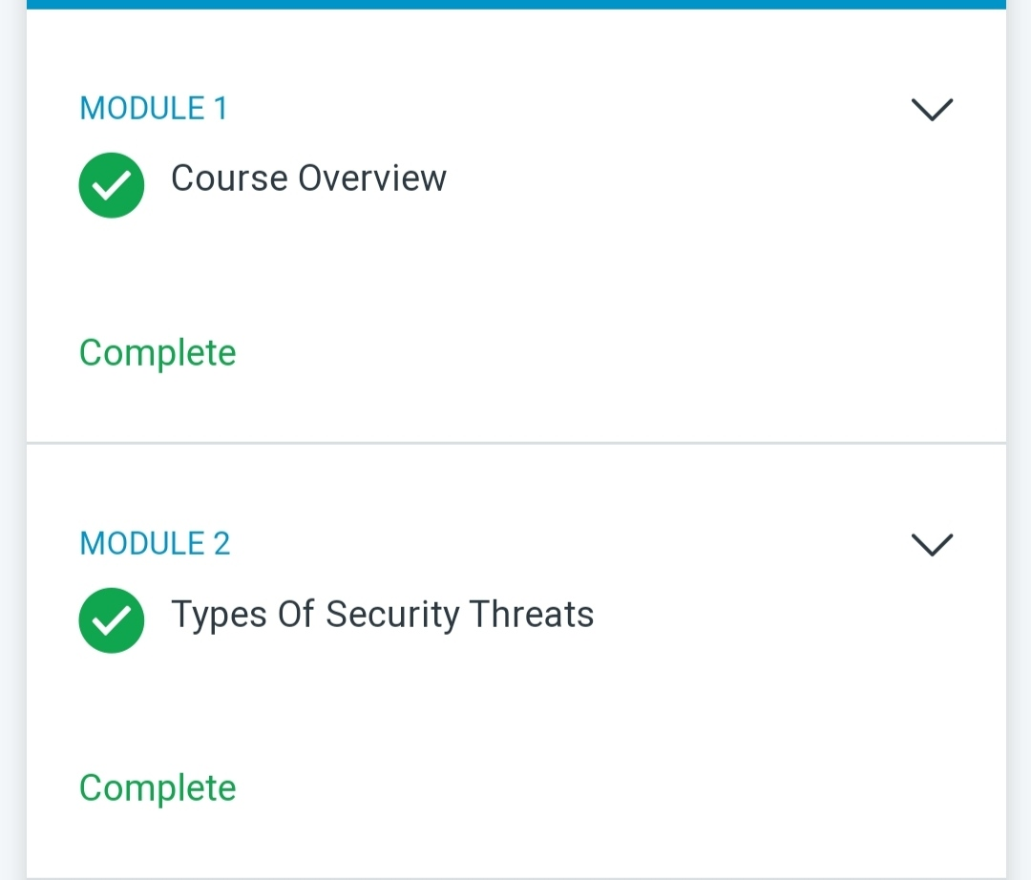

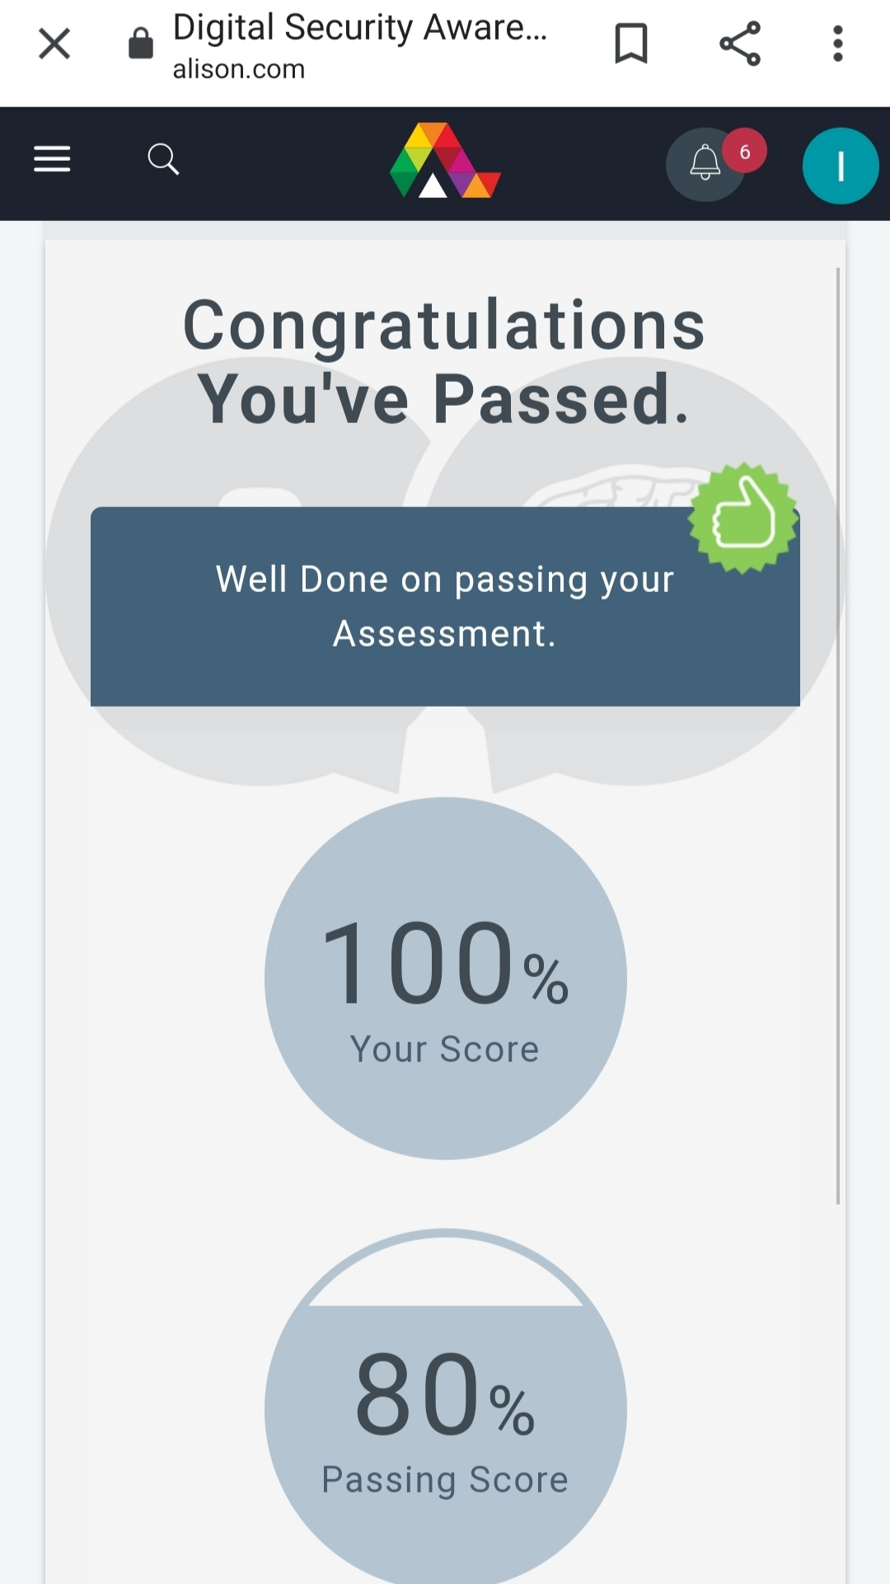

**Coding Challenges:**

Today I solved 3 coding challenge,

1. **Create the SLL, and then Reverse the Link in SLL until Head becomes NULL. Each Time Reversing the Link, Head must be moved to next immediate node.**

2. **Write a C program to implement SRTF process scheduling.  
Input: A set of processes with their burst time and arrival time  
Output: The processes scheduled based on the arrival time and a smaller burst time.**

3. **Write a C program to construct a singly linked list by removing duplicate elements in the sorted linked list  
Description:  
Take a sorted list and traverse the list. Compare the current node element with next adjacent node. If it is same then delete second element, if not retain. Finally print the resulting list.  
Sample output:  
Given list {1,2,2,3,3,3,4}  
Resulting list {1,2,3,4}**

